# INFO8240 Assignment 2

## Name: Nicholas Collins, Hassan Nahhal, Sung Joe Kim, Changho Choi

### Question 1

The artricle at <https://msdn.microsoft.com/en-us/library/orm-9780596527730-01-04> mentions the fact that an opaque façade is stringent, allowing access to only selected operations, and therefore a transparent façade is needed when users want to get at the individual operations of particular subsystems.

In the case of the Airline reservation system, an opaque façade would be appropriate to use when customers are using the system. This is because anything open to the public online or for someone other than employees of a company would have restrictions on what they could do. Customers and potential customers can view flight information and perform a fixed set of operations. Therefore an opaque façade for customers and potential customers is appropriate.

For the same system, employees have access to a wider range of operations, and therefore a transparent façade is more appropriate in their case. You would want to allow employees access to operations like adding flights and aircraft and other things unavailable to customers. So a transparent façade for employees would be appropriate.

It is also possible that different employees may require opaque facades that still allow the use of more operations than the opaque customer façade, one, i.e. a high level manager might use a transparent façade but a lower level employee might use one that is opaque but still allows the use of more methods than an opaque façade for customers.

In the case of additions or changes to the system, it would be necessary to determine which set of services is affected, since one set of services is for customers, any changes or additions to that part of the system would use the opaque façade for customers. In the case of the second set of services which is used by employees, changes would have to be made to the transparent façade or several opaque facades allowing different levels of access as described above.

### Question 2

In the code, all component at the domain model is included. Additionally, *GotoJail, Jail Square*, and *Cup* classes are included. Cup class, which is defined as Singleton, is mentioned at Pure fabrication at the text book.

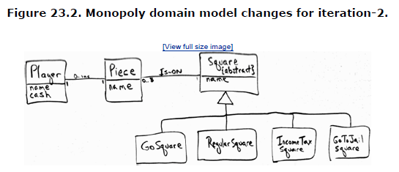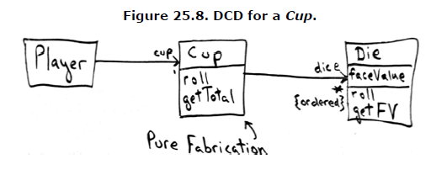 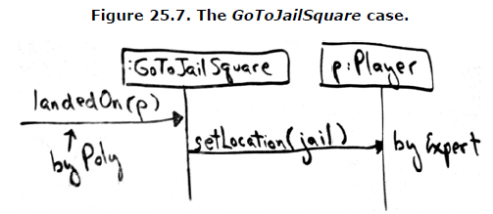

### Question 3

It is commented as “** Refactoring” where code is refactored.

### Question 4

At Air Craft, angle nose and height variable is coupled. That is, if angle nose is up, the height of aircraft get higher, vice versa. Speed can also related with height, but it is not considered at this answer due to complexity.

And for variation amount height can be *speed * sin (NoseAngle) * time*, but due to complexity of time unit, we assumed as *speed * NoseAngle * 0.05 where 0.5 is a coefficient for scaling*

*Aircraft Engine is ON*

*Aircraft increasing speed by 20 km/h*

*Aircraft current speed is 20 km/h*

*Aircraft increasing speed by 20 km/h*

*Aircraft current speed is 40 km/h*

*Aircraft reached target speed: 40 km/h*

*Aircraft maintains speed: 40 km/h*

*Aircraft reached the take off area*

*Aircraft stopped*

*Aircraft is waiting for ack*

*Aircraft increasing speed by 20 km/h*

*Aircraft current speed is 20 km/h*

*…*

*Aircraft increasing speed by 20 km/h*

*Aircraft current speed is 200 km/h*

*Aircraft reached target speed: 200 km/h*

*Aircraft maintains speed: 200 km/h*

*Aircraft reached MAX speed: 200 km/h*

*Aircraft's Nose Angle: 30*

*Aircraft goes into airborne state*

*Aircraft's Nose Angle: 30*

*Aircraft has increased its current height to 600 m*

*…*

*Aircraft's Nose Angle: 30*

*Aircraft has increased its current height to 2000 m*

*Aircraft reached target height is 2000 m*

*Aircraft's Nose Angle: 0*

*Aircraft maintains its height 2000 m*

*Aircraft reached near destination*

*Aircraft's Nose Angle: -30*

*…*

*Aircraft has decreased its current height to 200 m*

*Aircraft's Nose Angle: -30*

*Aircraft was just landed*

*Aircraft has decreased its current height to 0 m*

*Aircraft decreased speed by 20 km/h*

*Aircraft current speed is 180 km/h*

*…*

*Aircraft current speed is 120 km/h*

*Aircraft decreased speed by 20 km/h*

*Aircraft current speed is 100 km/h*

*Aircraft decreased speed by 20 km/h*

*Aircraft current speed is 80 km/h*

*Aircraft decreased speed by 20 km/h*

*…*

*Aircraft current speed is 20 km/h*

*Aircraft decreased speed by 20 km/h*

*Aircraft current speed is 0 km/h*

*Aircraft stopped*

*Aircraft Engine is OFF*